Public Auction

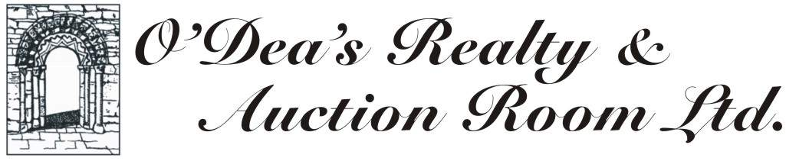


Prominent Hog’s Nose Landmark

5 High St and 15 High St, Trinity, Trinity Bay, NL,

Each parcel to be sold independently.

Procedures and conditions

Two parcels of land on Hog’s Nose in the Town of Trinity, Trinity Bay located at 5 High St and 15 High St as described in the surveys and photos at the bottom of this site.

- The Town of Trinity will sell the Property by public auction. The auction will be held at the offices of the Town of Trinity located at the BEDA Building, Route 239, Trinity at 11:00 AM on Friday, 23 Sept 2016.

- Bidders must register with the Town of Trinity prior to being able to bid. Bidders may bid through agents provided the name and address of the bidder and agent is disclosed by depositing with the Town Clerk prior to the commencement of the auction a power of attorney in the form attached.

- To register for the auction, all bidders are required to deposit $5,000.00 in cash or by a certified cheque or bank draft payable to “O’Dea’s Realty and Auction Room Ltd., In Trust”.

- The Property will be sold “as is where is” to the successful bidder. The Town of Trinity shall not be obliged to provide an abstract or other evidence of title.

- On the conclusion of the auction, the successful bidder’s deposit of $5,000.00 will be cashed and applied to the taxes, interest and costs owing in respect of the Property (“Arrears”). In the event the amount of the highest bid is in excess of the Arrears, the balance, plus HST, (HST at 15% will be included in your bid price), shall be paid as follows:
  - A certified cheque or bank draft payable to the Town of Trinity in an amount representing the difference between the $5,000.00 deposit and the amount of (i) outstanding taxes, plus (ii) interest to date of auction plus (iii) anticipated town costs. Anticipated town costs will be known within a few minutes after the final hammer price has been determined for each parcel of land. Successful bidders should budget in a range from $14,000-$18,000 for (i) to (iii) above for each property with the understanding that the final estimate of town costs will not be determined until the auction hammer price for each parcel has been determined. That supplementary deposit is due by 3 PM on auction day by certified cheque or bank draft with the balance due on closing day by certified cheque or bank draft.
  - A certified cheque or bank draft in the amount of the balance of the Purchase Price on the closing of the sale.
Failure of the successful bidder to complete the sale will result in the successful bidder forfeiting the amounts set out to the Town of Trinity.

- The successful bidder must enter into an agreement for sale in the form provided by the Town of Trinity which will provide that the sale shall close within 30 days of the auction date. The Town of Trinity reserves the right to extend the completion of the sale for any reason including, but not limited to, the requirement to obtain a clearance from the Province of Newfoundland and Labrador as to whether the property is Crown Land.

- The sale to the successful bidder is conditional on a subsequent clearance from the Province of Newfoundland and Labrador that the Property is not Crown Land. If, subsequent to the auction, the Property is found to be partly or wholly Crown Land, the sale will be considered null and void and the Town of Trinity will return all monies paid by the successful bidder in respect of the sale.

- The Town of Trinity will provide the successful bidder with copies of any title documents relating to the Property which are in its files. At the closing of the sale, the Town of Trinity warrants title only as being free from encumbrances of the Town of Trinity. For greater certainty, the Town of Trinity does not warrant title as being free from any adverse claim either before or after the sale by auction. With respect to the Property, the Town of Trinity makes no representations, warranties, or guarantees, expressly or by implication, in connection with title, encumbrances, description, location, dimensions, condition, compliance with governmental regulations or fitness for a particular purpose of the Property.

- The Town of Trinity will provide the successful bidder with a deed of conveyance which will vest the Property in the name of the successful bidder in accordance with section 147 of the Municipalities Act, 1999 which states:

Vesting of property
147. The conveyance referred to in section 146 shall be conclusive evidence that the provisions of this Act with reference to the sale of the real property described in that conveyance have been fully complied with, and everything necessary for the legal perfection of that sale has been performed, and shall have the effect of vesting the real property in the purchaser, his or her executors, administrators or assigns absolutely free from encumbrances except a claim of the Crown and an easement.

- Conditions Of Sale By Public Auction

  - The highest approved bidder will be the buyer subject to:
    - the reserve price and such reserve / minimum will not be disclosed prior to the auction; and
    - the seller’s approval.
  - The Town of Trinity reserves the right to bid in at the auction.
  - The bidder warrants the ability to enter and complete the Contract of Sale in accordance with its terms, (without conditions such as financing, inspection, etc) and without modification.
  - Any person bidding on behalf of another person must provide the Town of Trinity with a copy of a Power of Attorney, in the form attached, at the time of registration and such authority may be subject to approval of the Town of Trinity, otherwise the bidder will be taken to be acting on his/her/its own behalf. Realtors are welcome to participate on behalf of their clients provided the following is delivered to the Town Clerk prior to the commencement of the auction: (i) the name of the client and related data and (ii) a power of attorney, in the form attached. Any commission arrangements are to be agreed between the realtor and the bidder as no commission is payable by the Town of Trinity.
  - The Auctioneer has the discretion to refuse to accept any bid from any person. A bid will be taken to be accepted and irrevocable unless the Auctioneer, immediately after it is made, refuses it.
  - The decision of the Auctioneer is final in all matters relating to the auction and no bidder has any right of recourse against the Auctioneer or the Town of Trinity. If there is any dispute over a bid, the Auctioneer may:
    - re-open the bidding and resubmit the Property for sale starting with the highest bid previously accepted; or
    - determine the dispute in any other way the Auctioneer considers appropriate in the Auctioneer’s absolute discretion.
  - Immediately on the fall of the hammer, the bidder of the highest bid accepted must sign, as buyer, the Contract of Sale in the form supplied by the Town of Trinity and pay the amount set out in 5a above. The balance of the Purchase Price, plus HST if applicable, shall be paid on the closing of the sale.
  - The Auctioneer shall witness the Contract of Sale immediately after the auction has ended. The successful bidder agrees that the Auctioneer is not acting as the bidder’s agent or otherwise represented by the Auctioneer and the Auctioneer’s only obligation is to provide information relating to the auction and conduct the auction on behalf of the Town of Trinity.
  - If the successful bidder does not pay the full Arrears, at the option of the Town of Trinity:
    - the result of the auction will be treated as invalid and the Property may be resubmitted to public auction at the risk and expense of that bidder; or
    - the Town of Trinity may affirm the Contract of Sale and pursue its legal and other remedies against the bidder as it sees fit.
  - Other special conditions may apply and will be communicated on the day of the auction.
  - Only registered bidders or designated power of attorney will be able to bid and dialog at the auction by bidders or designated power of attorney will simply be permitted to place bids. Those engaged in dialog perceived as disruptive to the auction will be asked to leave in any way by the auctioneer or Town Manager will be asked to leave the premises.

- The Town of Trinity reserves the right to waive any or all of the terms and conditions of the auction.
- Bidders should note that they are responsible for all due diligence association with investigations associated with zoning, access and all other matters with respect to both parcels of land. Bidders should also note that both parcels would most likely require sewer pumping stations in order to provide town sewer service to each parcel.
- Anyone who may be successful in bidding on bother 5 and 15 High Street will be required to close on the purchase of both at the same time

9b

To bid at an auction:
        - It cannot be emphasized enough that bidders need to attract the Auctioneer's attention by using a gesture such as raising your hand, calling out or nodding your head when you catch the Auctioneer's eye.
        - Don't hesitate to indicate your interest when the auction starts and the Auctioneer calls for your bids. Your bid does not have to be the amount nominated by the Auctioneer, although it is at the Auctioneer's discretion as to whether or not to accept a bid.
        - Don't leave your bidding until the last moment - you may just miss the Property.
        - Remember, subject to the reserve price, when the hammer falls the highest bidder is the purchaser.
        - Bidders will register in advance and will need to provide photo ID in the form of a driver’s license or passport or other ID as deemed appropriate by the vendor’s agent.
        - Closing date will be within 30 days from the date of the auction.
9c
Registration Form
Public auction of 5 and 15 High St, Trinity, NL

Name
Name of Business
Bid Number
Driver’s License ID number
Mailing address home

Mailing address business

Business Phone number
Cell Phone number
Home Phone Number
Email address

I have read and agree with all of the contents of the document titled “Public Auction, 5 and 15 High St, Trinity, NL” and all conditions outlined therein. Furthermore, I hereby deliver a certified cheque, bank draft or cash in the amount of $5,000.00 payable to “O’Dea’s Realty and Auction Room Ltd., In Trust” in order to participate in the auction. In the event I am the successful bidder, I agree to pay the Purchase Price, plus HST if applicable, as follows:
A certified cheque or bank draft payable to the Town of Trinity in an amount representing the difference between the $5,000.00 and the amount of (i) outstanding taxes, plus (ii) interest to date of auction plus (iii) anticipated town costs. Anticipated town costs will be known within a few minutes after the final hammer price has been determined for each parcel of land. Successful bidders should budget in a range from $14,000-$18,000 for (i) to (iii) above for each property with the understanding that the final estimate of town costs will not be determined until the auction hammer price for each parcel has been determined. That supplementary deposit is due by 3 PM on auction day by certified cheque or bank draft with the balance due on closing day by certified cheque or bank draft.

I agree that should I fail to complete the sale I will forfeit the amounts set out above to the Town of Trinity and the Contract of Sale shall be deemed to be null and void.

Signature of Registrant

Date Time

Witnessed by

9d
Contract of Sale

I/We

of ____________________________________________________ (“Purchasers”) having inspected__________________________, Trinity, in the Province of Newfoundland and Labrador (“Property”) offer to purchase the Property from the Town of Trinity (“Vendor”)

At a price of $____________________________ plus HST, if applicable, in lawful money of Canada (“Purchase Price”) by certified cheque or bank draft upon the following terms and conditions payable as follows:

- $5,000.00 payable to “O’Dea’s Realty and Auction Room Ltd., In Trust” as a deposit with my/our bid registration form,
- $_________________ being the difference between the $5,000.00 deposit and the amount of (i) outstanding taxes, plus (ii) interest to date of auction plus (iii) anticipated town costs. That supplementary deposit is due by 3 PM on auction day
- $_________________ being the balance of the Purchase Price on or before __________________________ (“Closing Date”)

On the following terms and conditions:
1. The Vendor does not warrant the location, dimensions or condition of the Property and that the sale is pursuant to section 147 of the Municipalities Act 1999.
2. Vacant possession to be given by the Vendor and the transaction of purchase and sale shall be completed on or before the Closing Date.
3. This agreement constitutes a binding contract of purchase and sale, and time shall in all respects be of the essence hereof.
4. This agreement shall enure to the benefit of and be binding upon all parties hereto, and their respective heirs, executors, administrators, successors, and assigns.
5. The Purchaser agrees that if Harmonized Sales Tax applies to this sale then such tax will be added to the Purchase Price.
6. The Purchaser agrees that the Auctioneer is not acting as the Purchaser’s agent, and the Auctioneer’s only obligation is to provide information relating to the auction and conduct the auction on behalf of the Town of Trinity.
7. I agree to the above terms.

Dated at the Town of Trinity, NL, on _________________________

Purchaser

Witness

Purchaser’s Solicitor

Vendor

Witness

Vendor’s Solicitor

Power of Attorney

KNOW ALL BY THESE PRESENTS that I/we, ______________________________________, of , in the Province of
hereby appoint
of , in the Province of Newfoundland and Labrador my/our attorney for us and in my/our name

1. To act for me/us in connection with the auction and sale of certain land by the Town of Trinity situate at 5 and 15 High St, Town of Trinity, Trinity Bay, Newfoundland and Labrador, and in connection therewith,
2. To sign and execute on my/our behalf all forms, contracts, deeds, releases, instruments, undertakings and other documents, and
3. To make and deliver payments as required in connection therewith,
All pursuant to the procedures and conditions of Public Sale issued by the Town of Trinity and attached hereto which I/we acknowledge having read and agree to.
AND I/we hereby undertake to ratify everything which my/our said attorney shall do or purport to do by virtue of these presents.

IN WITNESS WHEREOF the Appointer(s) have hereunto their respective hands and seals subscribed and set at , on this _________ day of _________________________20 .

SIGNED, SEALED AND DELIVERED
by the Appointer(s), in the presence of: ___________________________O

_________________________________ ___________________________O

Survey and Survey Description 5 High Street, Trinity, Trinity Bay
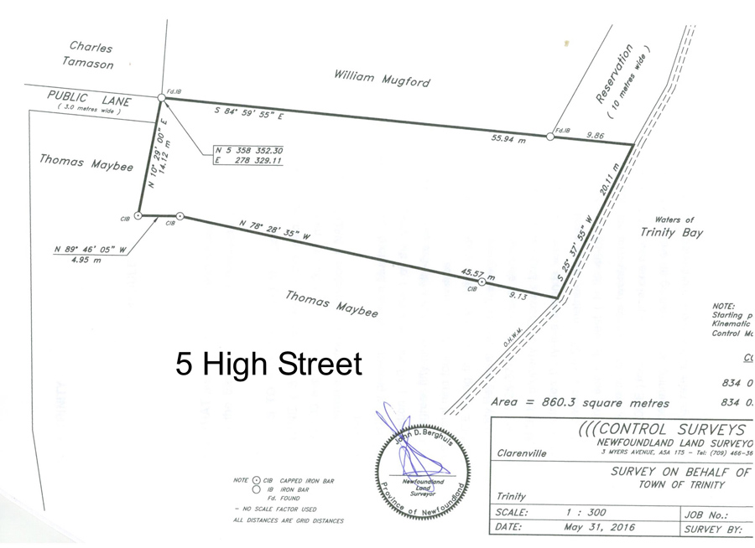

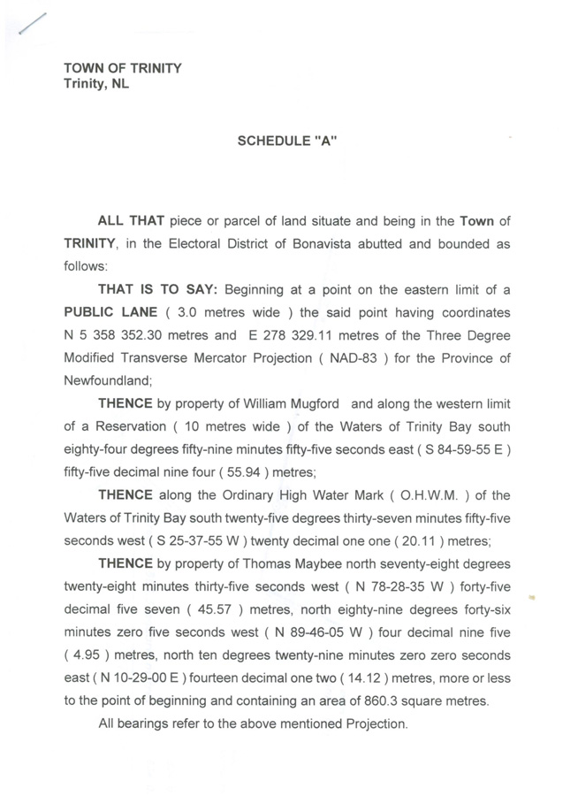

Survey and Survey Description 15 High Street, Trinity, Trinity Bay
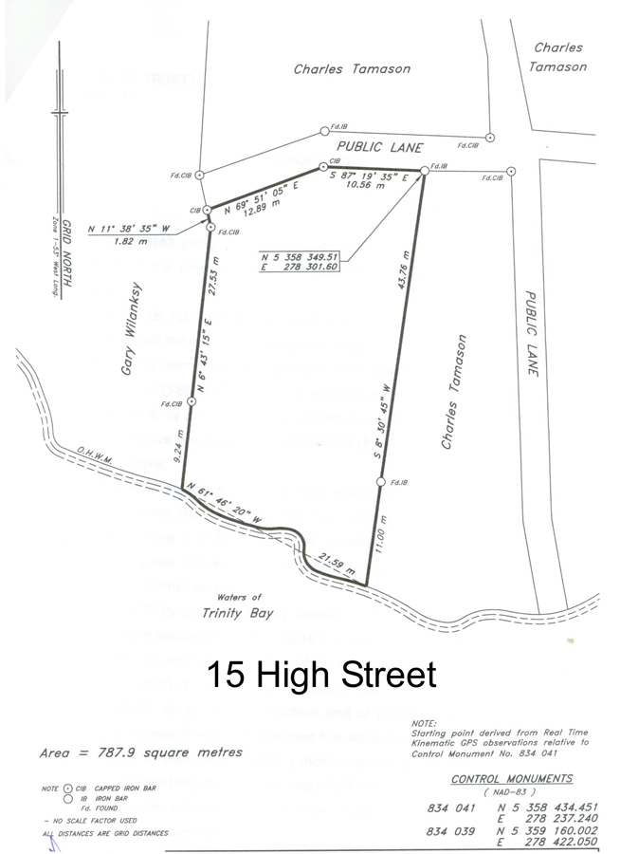

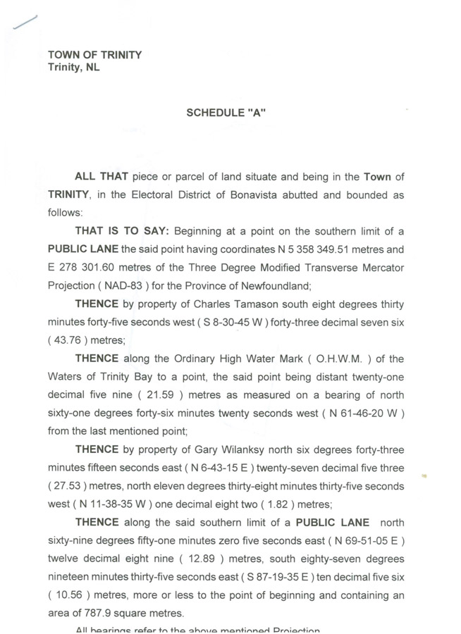
For additional information, interested parties can call Chris O’Dea at 685-6559 (area code 709) or Town Manager Linda Sweet at 464-3836 (area code 709)

Footnote from the Town of Trinity

The Town of Trinity has received the below questions regarding the auction of the two parcels of land on Hog’s Nose and has provided the following answers:

1) That the Town of Trinity is offering for sale two parcels of land with the implication that the buyer can reasonably access this land

Yes there are two parcels of land for sale. The land can be accessed within the boundary of the right of way. However, adjacent owners on either side of the right of way can give permission to use their land in the event that a wider access is required.

2) That the two parcels of land are and will be subject to municipal tax, at the same rate as all other accessible lands are within the Town limits

Yes the two parcels of land are subject to the same municipal taxes (property tax, water and waste water/septic) however as both parcels of land are below grade to connect to the Town infrastructure and the two lots are to small to accommodate a private septic system the property owners will need to install a lift station to connect to the Town waste water/septic system at their costs.

3) That the historic and current drawings indicate a couple of public roads/lanes are in the plan, allowing access to these parcels

Yes there is evidence of a public lane having been in this area that allowed access to these parcels of land.

4) Can the the Town of Trinity please confirm that it will assume responsibility to open these public roads for use within a reasonable timeframe once buyer(s) have completed purchase of the auctioned lands.

Upon sale of the property the buyer(s) can seek permission from the Town to open the lane way however it will be the responsibility of the purchaser to incur the expense(s) for its development, upkeep and maintenance (similar to what has taken place in other areas of the Town – Nuddick and Coleman’s Point) The Town will not be taking on the responsibility to open the laneway and completing any on-going maintenance or snow clearing.

An adjacent property owner on either side of the right of way can give permission to permit the access to be widened. The Town would not be involved other than issuing a permit for the work as the Town has no responsibility for maintaining the right of way.

